**Supplementary Materials**

**STEP-BY-STEP PROCESS FOR THE SMART TOOL**

**Step 1: Installing R**

1. Go to www.r-project.org and click on the CRAN link.

c

*Figure 1.* The R-Project website.

1. Click on the 0-cloud link.

*Figure 2.* The 0-cloud link.

1. Click on the link to download based on your operating system.

*Figure 3.* Download links based on OS.

**Step 2: Installing R Studio**

1. Go to <https://www.rstudio.com/> (now posit.co).

*Figure 4.* Visit posit.co.

1. Go to Products menu and in the sub-menu click on R -Studio IDE.

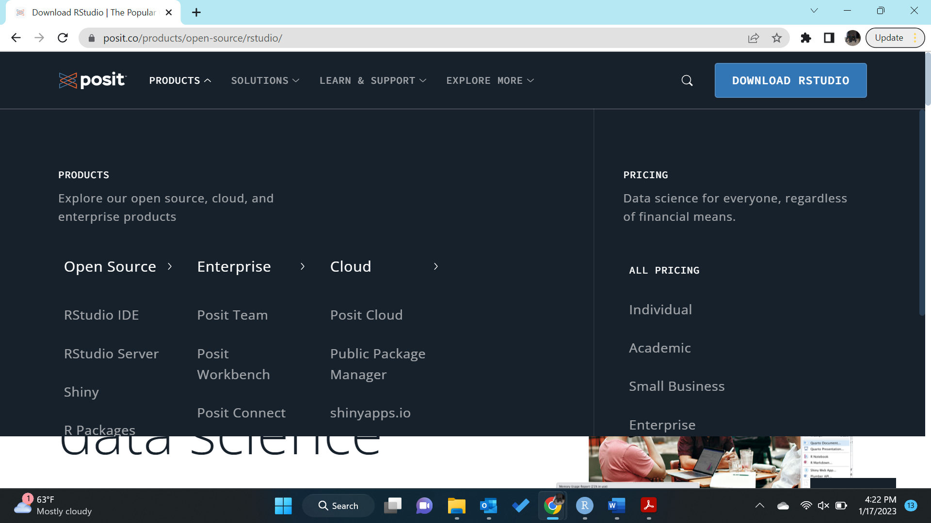

*Figure 4.* Click on RStudio IDE

1. Download the Open-source edition for R Studio.

*Figure 5.* Download link for RStudio.

**Step 3: Familiarize yourself with R and R Studio**

* Additionally, please also download R-tools which will be needed to pull data from WRDS.

**Step 4: Using the SMART tool**

1. Open[www.smartdatatool.net](http://www.smartdatatool.net) and navigate to Take me to the tool.

*Figure 6.* The SMART Tool homepage.

1. Navigate to Take me to the tool link and click on ROA1, ROA2, ROA3 and CEO Gender.

*Figure 7.* The SMART Dynamic Strategy Library.

1. Copy the code to R Studio and run the code.

*Figure 8.* Pasting the code in the R Studio console.

1. Select the folder to save the output file.

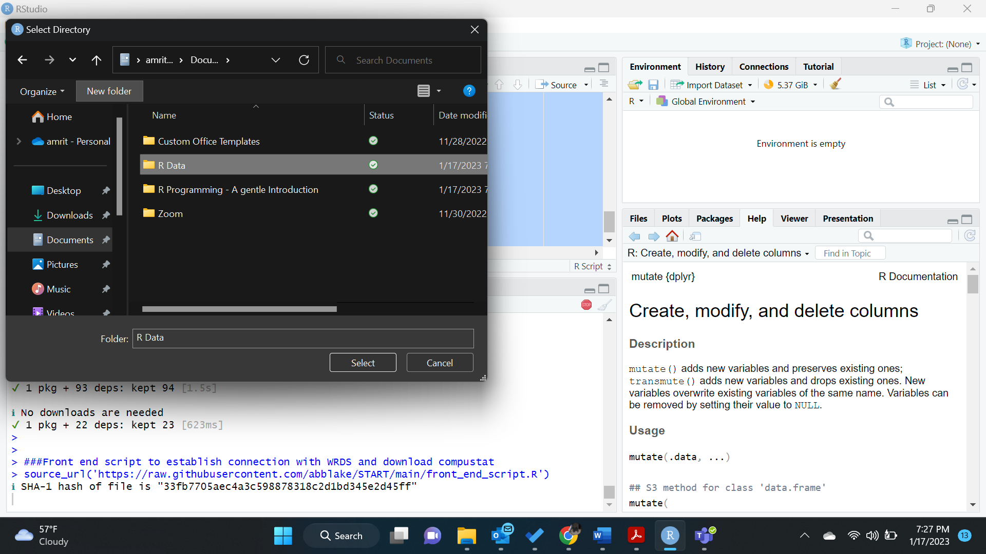

*Figure 9.* Select the folder for the output file.

1. Name the file.

*Figure 10.* Naming the output file.

1. Select the format to download.

*Figure 11.* Selecting the download format.

1. Select the start year for the data.

*Figure 12.* Selecting the start year for the data.

1. Select the end date.

*Figure 13.* Selecting the end year for the data.

1. Enter your WRDS Credentials.

*Figure 14.* Enter WRDS credentials.

The Data pull begins. It takes about 5 to 10 minutes to pull the data and will be found in the selected folder.